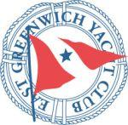
2017 Summer Series
May 17 – August 16
East Greenwich Yacht Club
East Greenwich, RI

AMENDMENT 1

- THE COURSES
7.1 The diagrams in Addendum A shows the courses using inflatable marks, including the approximate angles between legs, the order in which marks are to be passed, and the side on which each mark is to be left.
Amendment 1 ADDS the following course options to Addendum A:
GATE
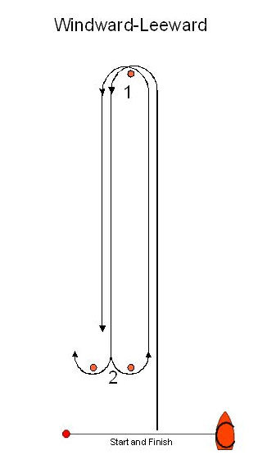
GATE COURSES WILL BE DISPLAYED ON COURSE BOARD:
G1 - Start, 1 , Finish
G2 – Start, 1, 2 , 1, Finish
G3 – Start, 1, 2 , 1 , 2 , 1 , Finish

Effective: 7/25/2017 Race Committee Chair: Charles Schifino

